Họ và tên: Đặng Nam Thiện Nhân

MSSV: 2011725

Lớp thí nghiệm: L03.

**BÁO CÁO PHẦN 1 – BÀI 1: INSTALL XAMPP**

1. To download the XAMPP installer for windows, visit the URL

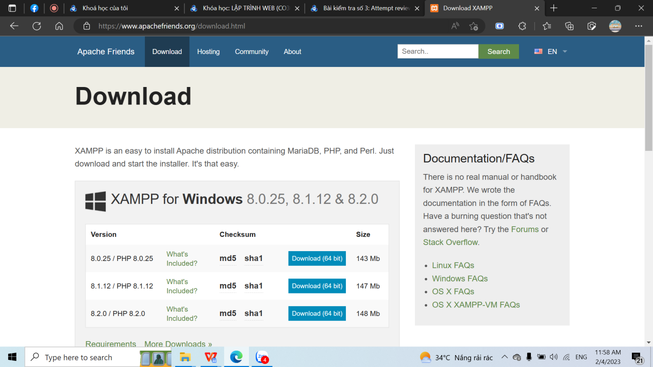

2 Download XAMPP:

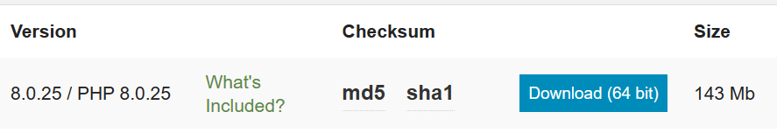

1. After downloading the installer, double click on the executable(.exe) file to start the XAMPP installation process. Click Yes, if User Account Control dialog box appears. Select your language in the dialog box then click OK
2. This dialog box below shows that you should avoid installing XAMPP to C:\Program Files. Click OK.

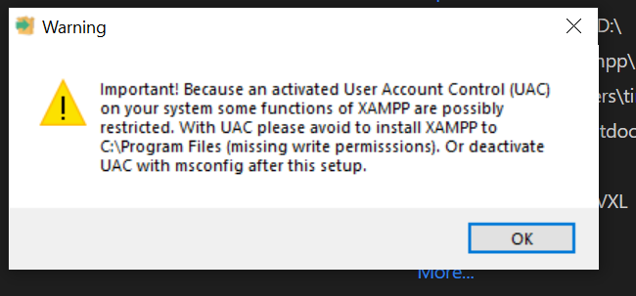

Click Next

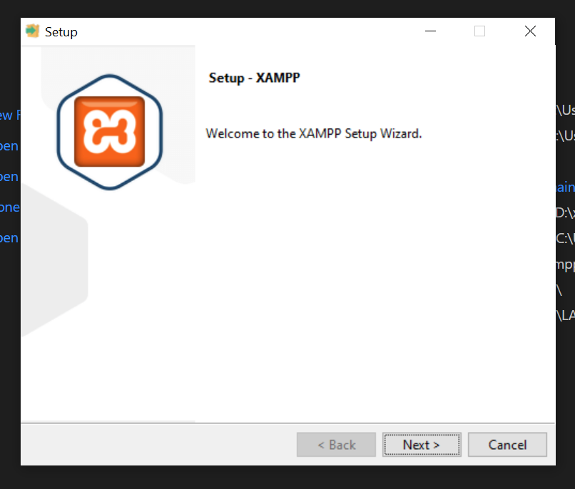

6) Verify that all the checkboxes are checked, then click Next.

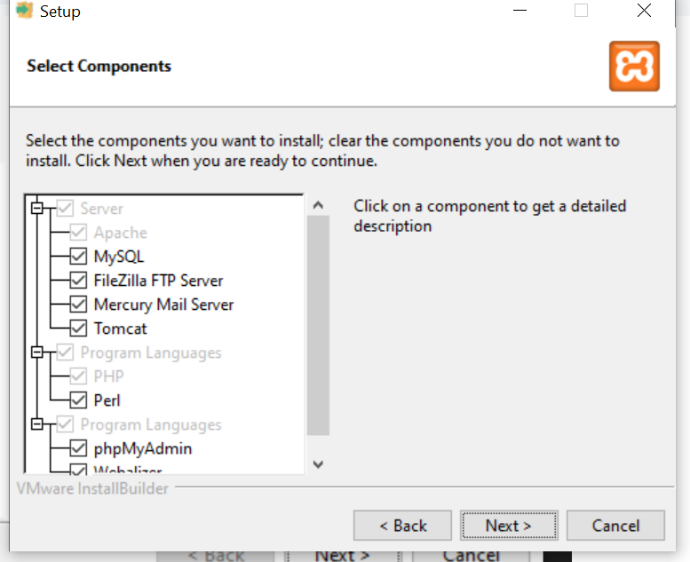

Verify that the Destination Folder is set to C:\xampp, (http://c/xampp) then click Install.

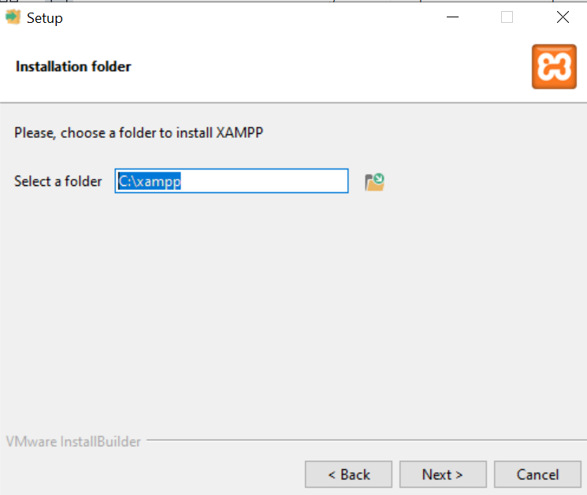

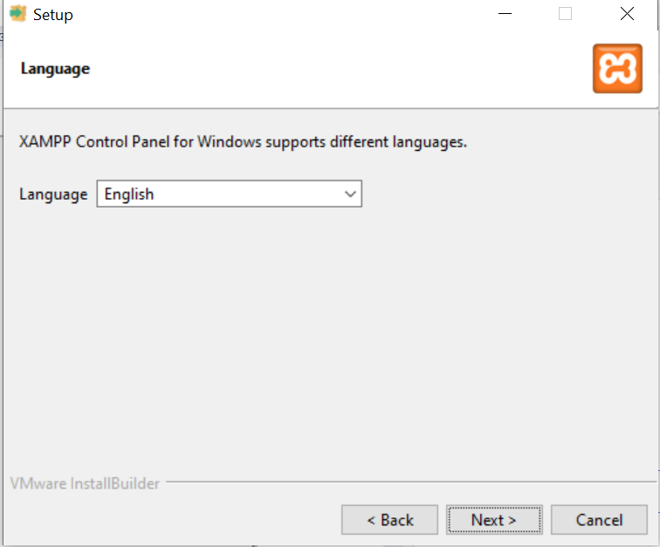

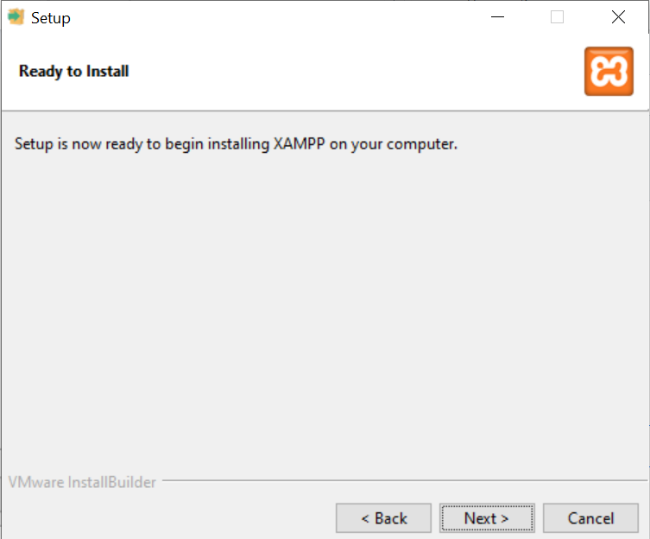

7) You will see the installation progresses. Wait for the process to complete.

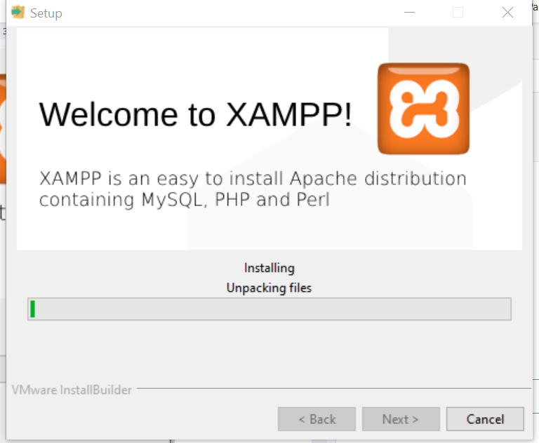

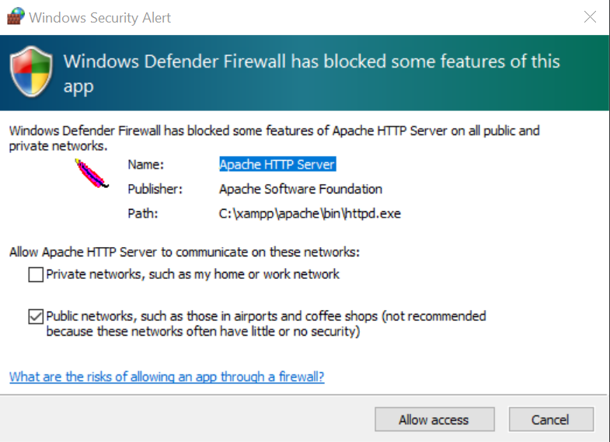

8) Click Finish to finish the installation process.

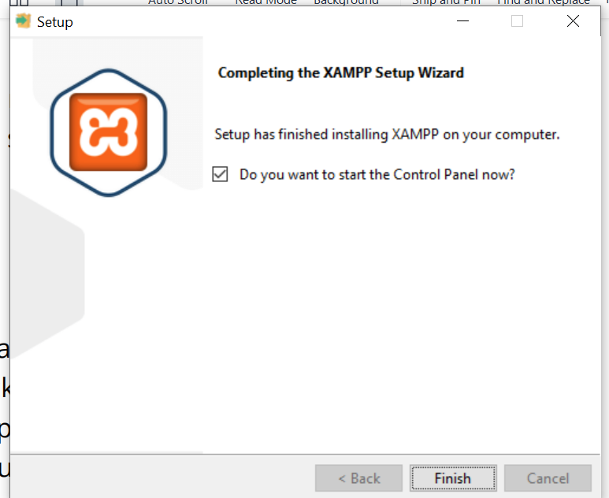

10) If the XAMPP control panel is not already started, find the XAMPP control panel in the start menu or the its desktop icon, right click on it and select "Run as administrator". Click "Yes" on the "User Account Control" popup, and wait for the XAMPP control panel to start. You will see the XAMPP control panel running.

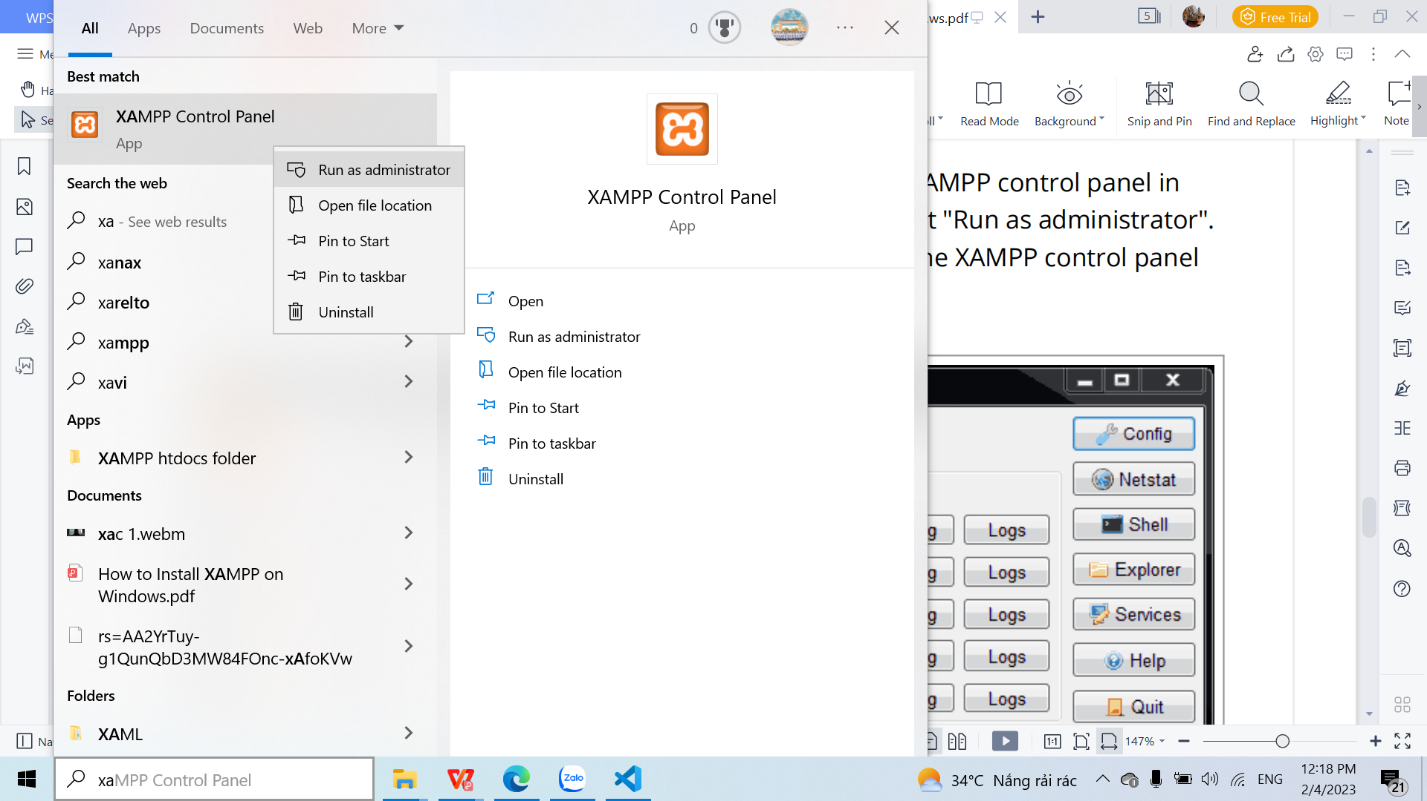

11) Click on the Start button next to Apache, and wait for apache to start. After the Apache has started, click on the Start button next to MySQL. Wait for MySQL to start. Both Apache and MySQL are running now.

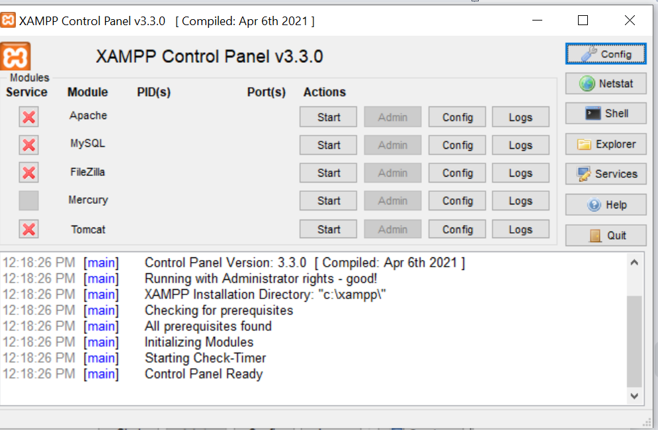

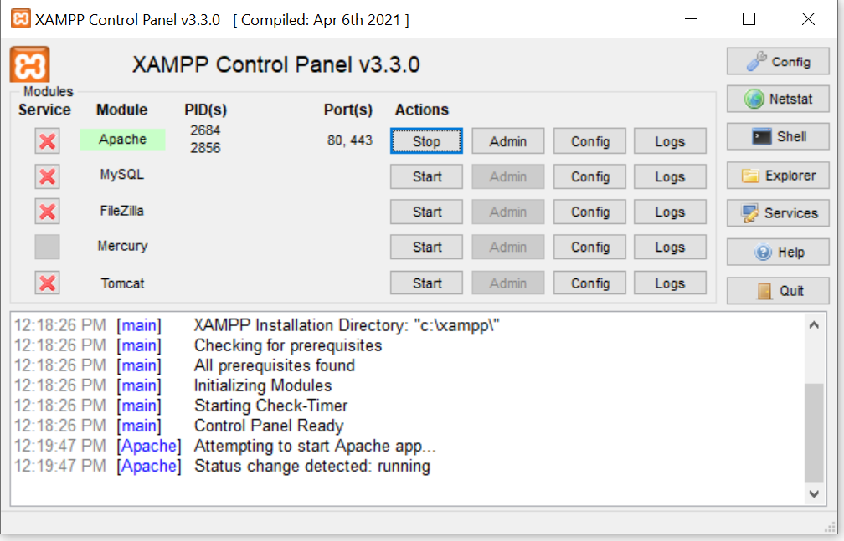

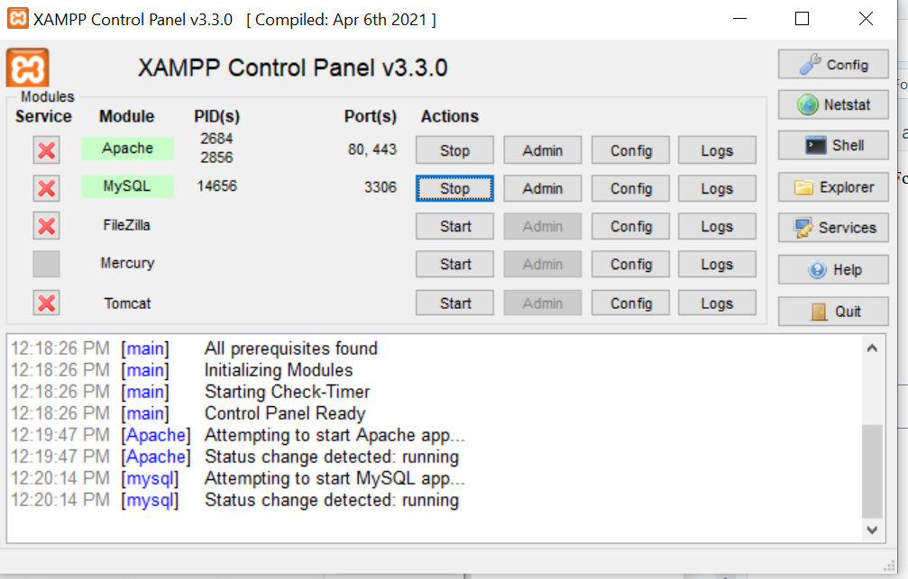

12) Now, open your web browser like Mozilla Firefox or Chrome.

